

HSM Integration
HSM Integration for POS Mojaloop OTP Encryption

Copyright © Applied Payments Technology Pvt Ltd

All rights reserved. No part of this document may be reproduced, distributed, or transmitted in any form or by any means, including photocopying, recording, or other electronic or mechanical methods, without the prior written permission of Applied Payments Technology (P) Ltd, 2nd Floor, Carnival Infopark -Phase 1, Kakkanad, Kochi 682042

Document History

Version | Amendment dates | Reason for Amendment | Author
v0.1 | 03-03-2020 | Initial Version | Anjitha N K
v0.2 | 04-03-2020 | Document format change | Anjitha N K
v0.3 | 05-03-2020 | Document changed as per review | Anjitha N K
v0.4 | 19-03-2020 | Changed the Transaction Flow | Anjitha N K
v0.5 | 20-03-2020 | Design Review | Renjith Palamattom
v0.6 | 20-03-2020 | Review updates | Jordy George
v0.7 | 21-03-2020 | Review | Renjith Palamattom

Glossary

Acronym | Full Form
APT | Applied Payments Technology
ATM | Automated Teller Machine
POS | Point of Sale
HSM | Hardware Security Module
OTP | One Time Pin
JSON | JavaScript Object Notation
JWE | JSON Web Encryption
DE | Data Element
MSISDN | Mobile Station International Subscriber Directory Number
ZMK | Zone Master Key
TMK | Terminal Master Key
3DES | Triple Data Encryption Standard
TA | Terminal Application
PVK | Pin Verification key

Table of Contents

1 Executive Summary 4
2 Introduction 4
3 Scope of Work 4
4 Diagram 5
5 Message Flow 6

Executive Summary
Hardware Security Module (HSM) is a secure device that performs cryptographic operations in a secure transaction processing environment. The purpose of this document is to explore the method that should be adopted to ensure secure transmission of One-Time-Pin for Mojaloop transactions using an HSM.
There are two use cases that are being explored for which the secure transmission is required.
- ATM Initiated Cash withdrawal
- Merchant Payment Authorized at POS

Introduction

This document explores the possibilities of HSM integration for secure transmission of Mojaloop transactions. The HSM commands used in this document follows the International Command set and Pin translation traces on an HSM.
The proposed solution consists of an HSM Endpoint that will be integrated with the OTP end point. The proposed solution is to perform the encryption of the OTP at the source (POS or ATM), transmit it securely in the standard ISO Pin Block field (DE 52), ensure the security of the OTP by performing crypto operations through the HSM end point and then securely transmit it using JWE signature through to Mojaloop.

Scope of Work

  - Generation of 3DES key for encryption
    - TMK > Encryption from Source (POS or ATM)
    - ZMK > Encryption from Terminal Application
    - ISO 9564 – Format 1 Pin Block Format
  - OTP encryption from POS driver to Terminal Application
    - The OTP is encrypted with a 16-digit TMK during the transmission from POS device to Terminal Application.
  - Development & Implementation of HSM End Point
  - Building HSM Command and translating PIN block
    - At Terminal Application/legacy switch
        - The encrypted OTP from the POS driver is combined with MSISDN,ZMK (stored in the database of Terminal Application),TMK and encrypted pin block for building the HSM command.
        - This command is sent to the HSM. The translated pin block t is taken from the HSM response and will be mapped to DE 52 of the ISO messages and sent to the LPS Adaptor via the legacy Switch.
    - At LPS Adaptor
        - The HSM endpoint is implemented and integrated in the Adaptor and Payer FSP
        - The HSM End Point will be connected to a physical HSM device.

      - Implementation of JWE between LPS Adapter and Mojaloop

Diagram

The proposed HSM Integration is implemented as given below. The Command used for encryptions is as per the Thales HSM protocols.
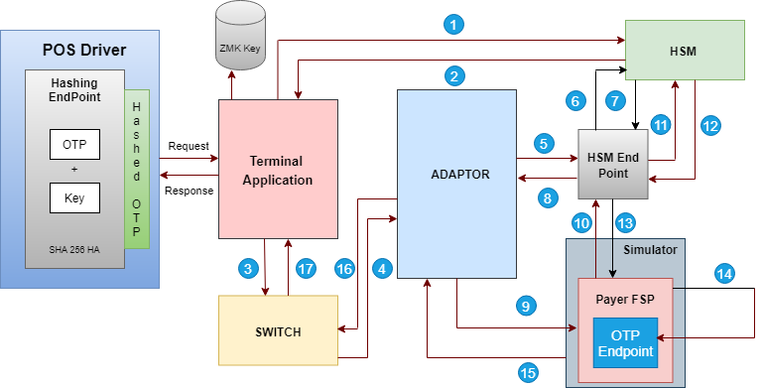
Fig. Ref: -

1. ZMK+ encrypted OTP+MSISDN
2. Encrypted PIN block component response from HSM
3.Transaction request to Switch
4.Transaction request to HSM End Point @ Adaptor
5.HSM command to decrypt DE 52 using ZMK
6.Response from HSM
7.Adding JWE signature in hashed OTP sent to Payer FSP
8.Decryption using TMK in HSM End Point @ Payer FSP.
9.HSM response back to Payer FSP
10.Clear OTP to OTP endpoint
11.Response to switch
12.Response to Terminal application

Message Flow

  - Customer initiates a Mojaloop Payment transaction on the POS device.
  - A preconfigured TMK is set at the POS device by the TA for encryption purposes.
  - The OTP entered is encrypted by the POS device using the TMK and the encrypted OTP is sent to the Terminal Application along with MSISDN (Including country code), and Transaction amount.
  - The TA will create an HSM command with the Encrypted OTP, MSISDN and an ZMK which is configured on the Terminal Application.
  - This command is sent to HSM by the Terminal Application for encryption.
  - The encrypted value returned on the response message from the HSM will be mapped to DE 52 of the ISO messages to the LPS.
  - The whole ISO Transaction message is sent to the LPS Adaptor via Switch by the TA.
    - Since DE 52 is populated with the encrypted OTP, the switch may optionally verify this using the same ZMK.
    - This would involve a key-exchange between TA and LPS Switch to exchange the ZMK.
  - The HSM endpoint is implemented on the LPS Adaptor.
    - The ZMK is shared with the HSM End Point at the LPS Adapter.
    - HSM End Point will intercept the PIN block from DE 52 and will decrypt it using the ZMK (same as that in the Terminal Application).
  - The decrypted component (which is still encrypted by the TMK) will be signed with the JWE algorithm and forwarded to the Payer FSP.
  - The HSM End Point is also implemented at the Payer FSP.
    - The TMK (same as that in Terminal Application) is shared with the HSM End Point implemented at the Payer FSP.
  - HSM endpoint will decrypt the JWE signature (certificate exchanged between the HSM End Points), which will provide us with the OTP encrypted under the TMK.
  - The HSM End Point then decrypts the OTP component using the TMK through the HSM.
    - The resultant of this operation would be the clear OTP.
  - This clear OTP will be sent to OTP endpoint for further validation.

